**Documentation**

**Created by**

Naphat Kosiyaporn 6332011721

2110215 Programming Methodology

Semester 2 Year 2020

Chulalongkorn University

**Fantasia**

**Introduction**

Fantasia was inspired by PVE card game that player use card to fight against monster such as monster train, slay the spire. Fantasia also combine some RPG factor to make the game more progressive such as level system.

**Rule**

Player will face 5 round of monsters, In each round, the player can play infinite turn as long as player’s hit point didn’t go below 0. Player start with 100 + level*10 hit point, and 20 starter card in the deck. At the start of each turn player will restore the mana point to 5 + level/5 mana and get to draw 5 card from deck. The player will then design which card to use to fight against monster.

The round will end when all monsters is defeated or player hit point go below 0. After each round player will gain correspond experience point that will be use to level up. The experience need for each level is 100 * 1.5^level. After finish each round, player can choose to continue to the next round, or go back to main menu.   
* The hit point will not be reset between round but all buff will be reset   
** If the level increase hit point will be reset to max  
*** Currently there are only 5 round into the game

**Example**

* When you got into the game for the first time there will be a prompt for you to input your name

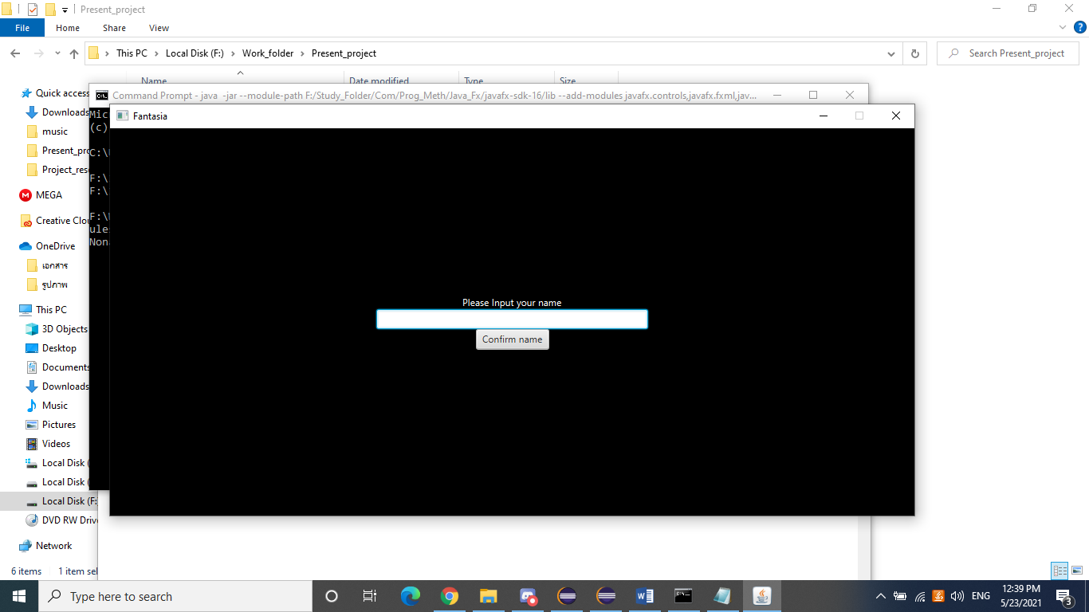

* After input the name you will be sent to main menu. The main menu consist of player’s info and Start/Exit button. Player’s info contain player’s name, level and experience. This will be consistence as long as you not delete the game. Play button will bring you to the battle scene at round 0, and Exit button will exit the game. Also the deleteSave button for delete the save
* 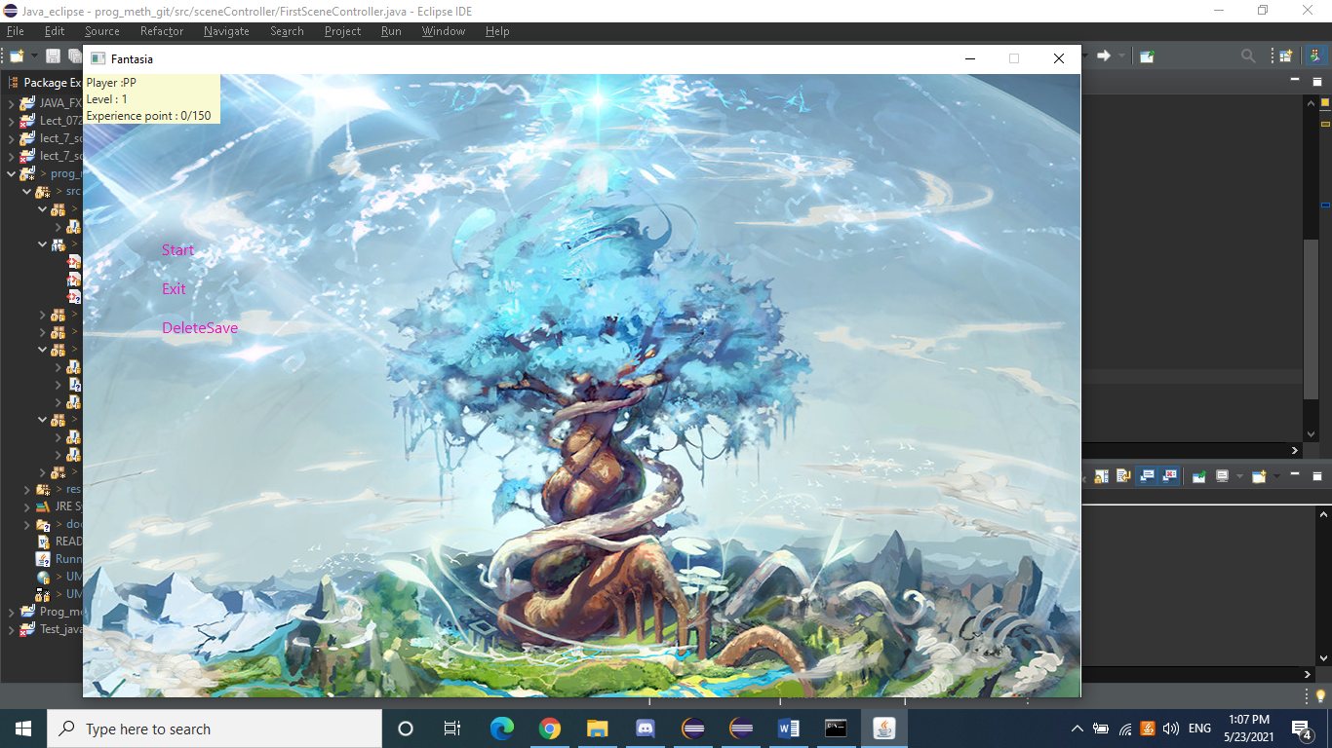
* In the battle scene you will found the enemy correspond to each round. And the card at the bottom of the window is the card that you have on hand. To your left is the Mana that you have. To your right is the end turn button .At the top of the screen is the statbar that will show player’s hit point and all buff that you have.
* 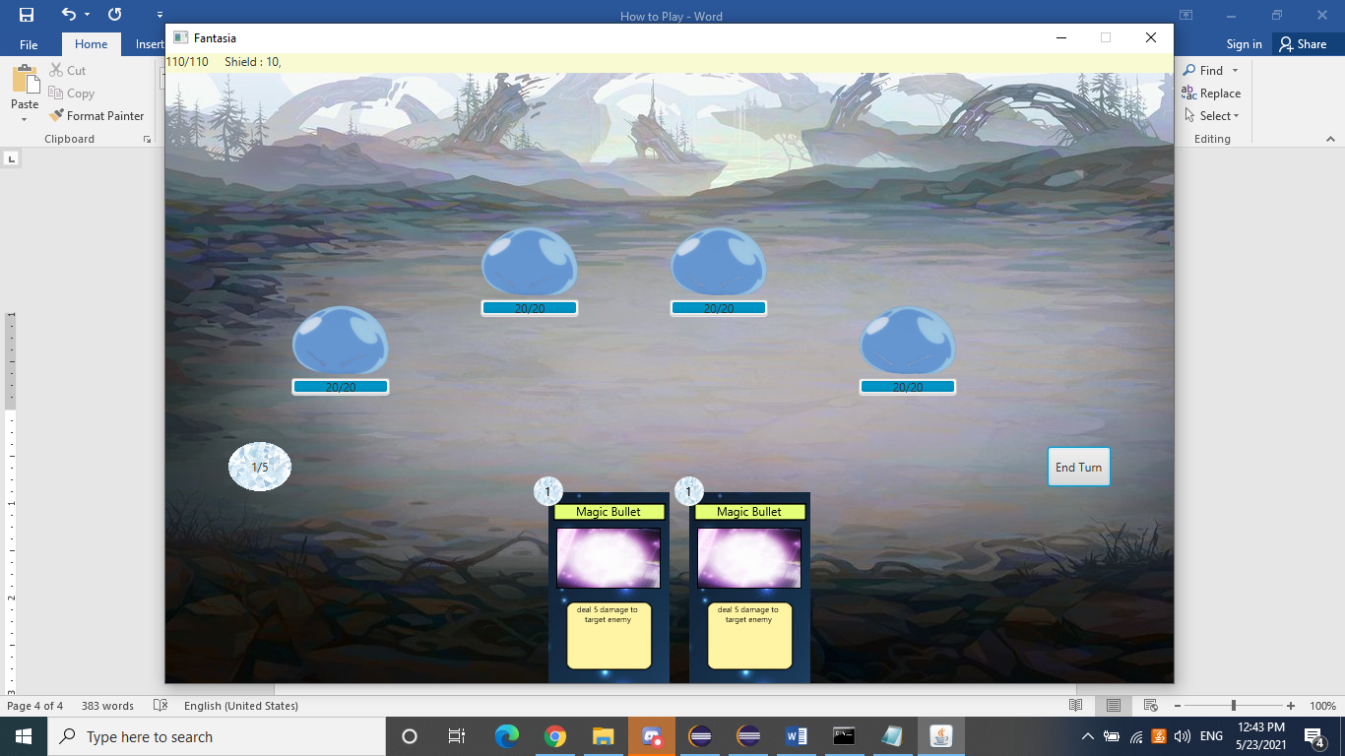
* .The card consist of 4 main component
  + The manacost at the top left corner
  + The Card’s name at the top
  + The Card’s image at the center
* The Card’s description at the bottom
* 
* To use the card there are 2 way both are drag and drop
  + The card that have to target
    - The card that have target need to be drag to the target monster and release to be use (There will be and arrow to indicate where your mouse is pointing)
    - 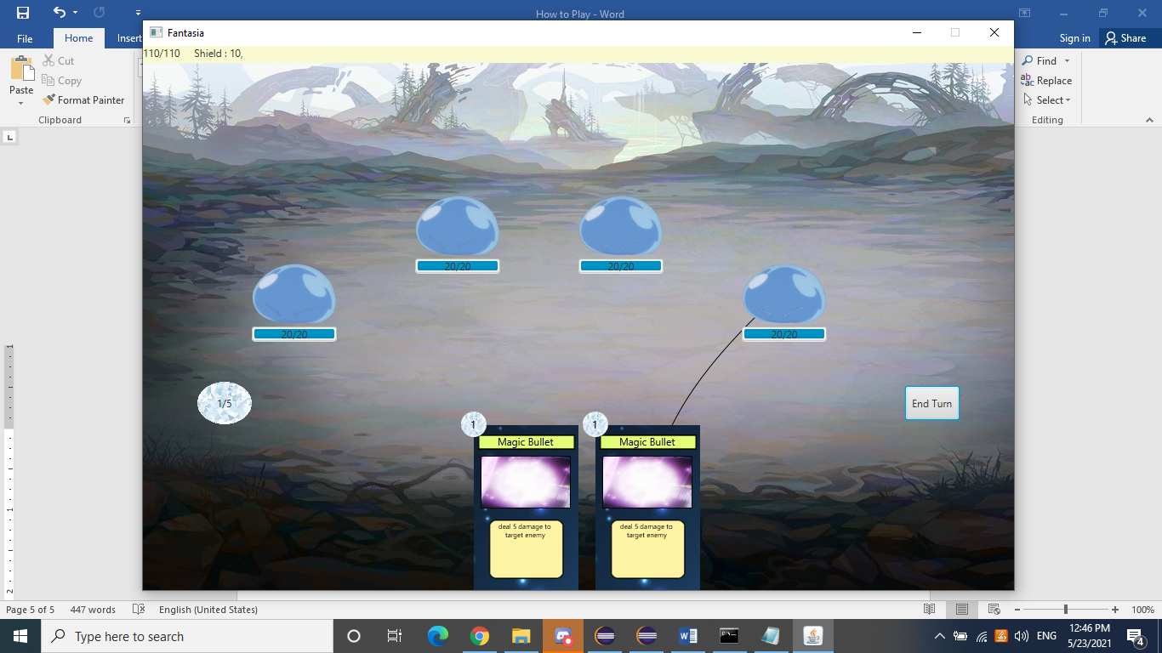

.

* + The card that have no target
    - The card that have no target can be drop anywhere on the screen for it to be activate (There will still be an arrow to show which card you are choosing)
* At the end of each round there are 2 type of screen. Winning and Losing
  + Winning screen will ask whatever you will continue or not and show your current experience point
  + 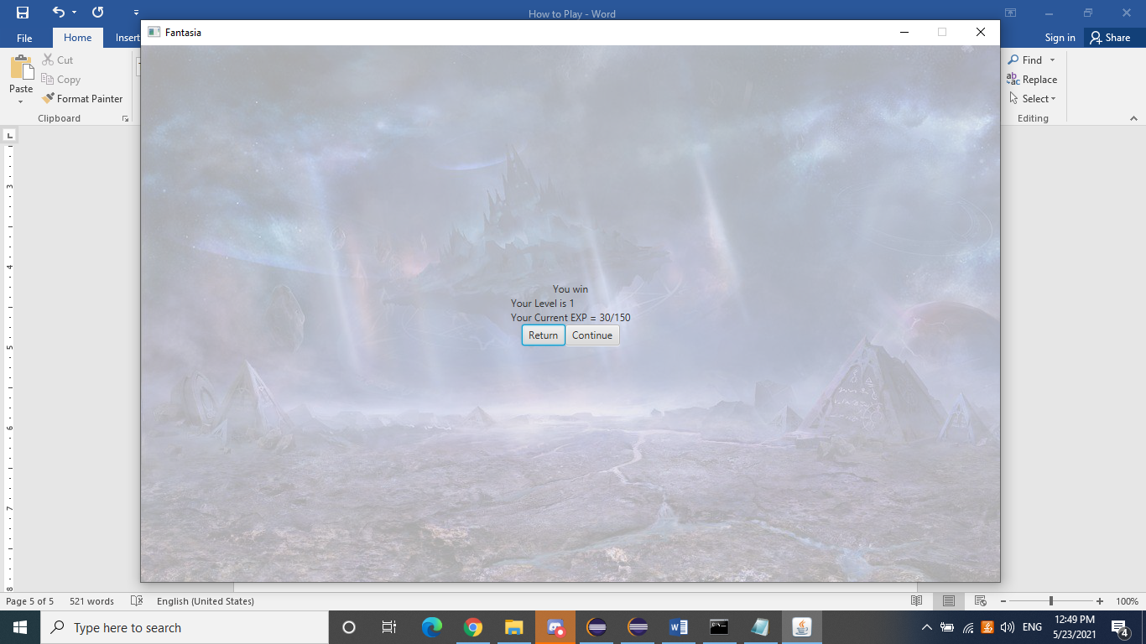
  + Losing screen will only show 1 option that is to return
  + 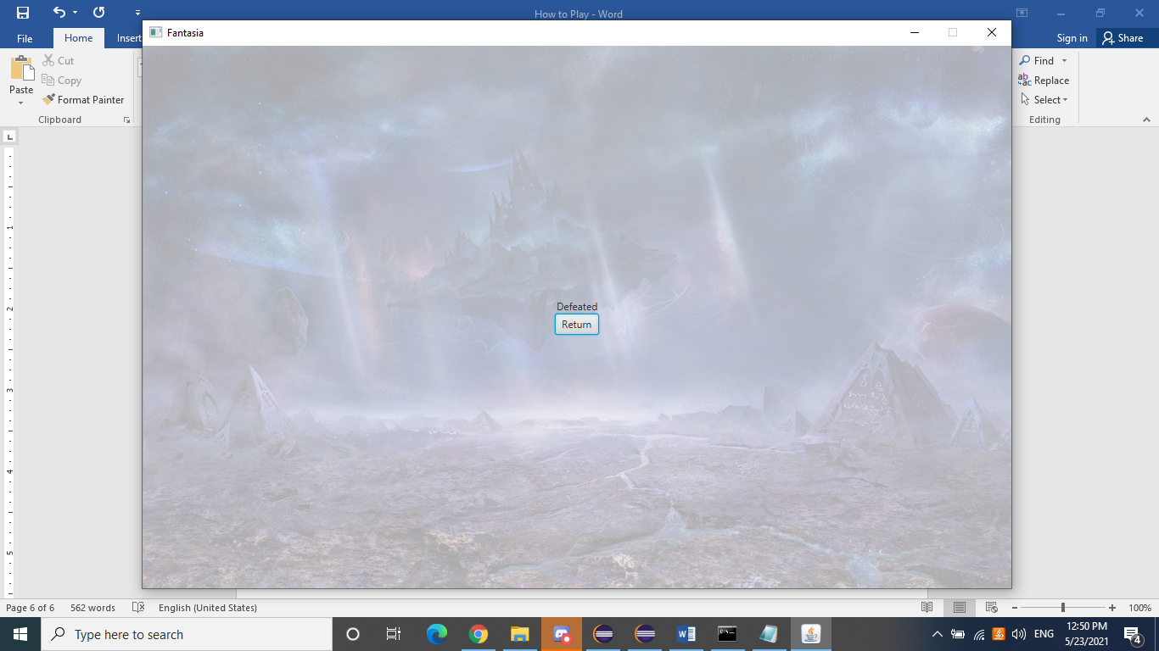
  + ** Losing and Winning will trigger that difference BGM
* .
* .

**Class Diagram**

